# Hive Project

**Created table :**

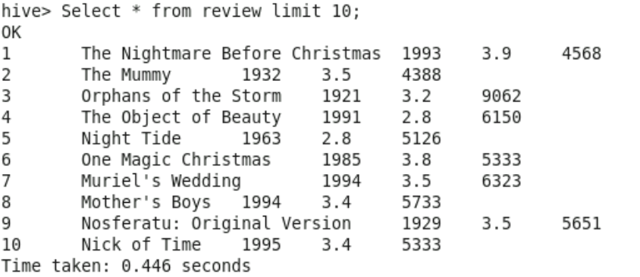

**1.Reviews between 1950 and 1960**



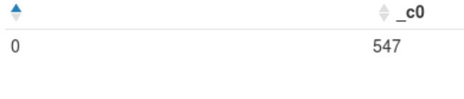

**2.** **Ratings > 4**

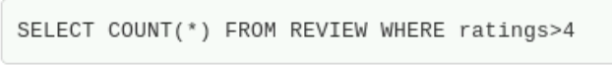

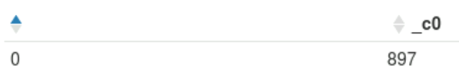

**3.Ratings between 3 and 4**



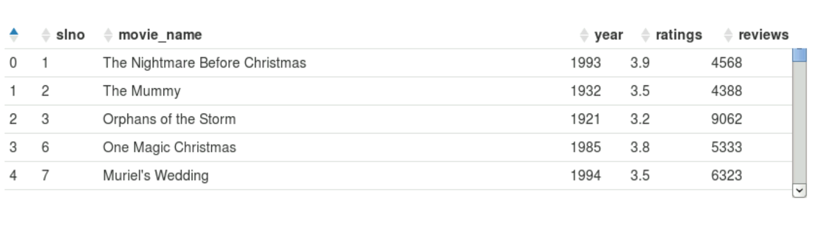

**4.**  **Reviews > 7200**

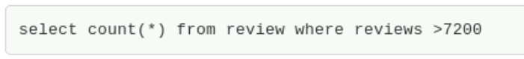

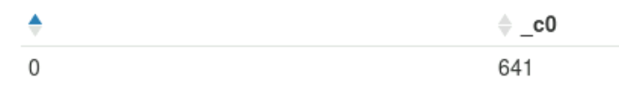

5. **Year Count**

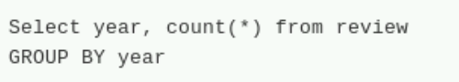

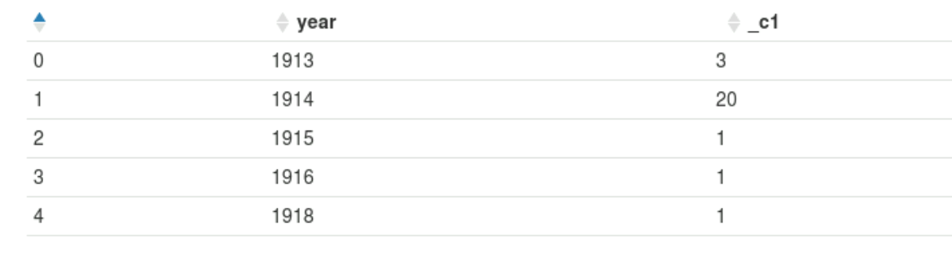

**6.** **Total Movies**

